**Miguel:** Hello teacher! Let me “inchrodus” myself - I'm Miguel Lardo, and she is my classmate Natalia.

**~~Natalia:~~**~~Thanks, Miguel! I'm Natalia Mucci. Today we’ll take you through the complete C++ installation process in VS Code.~~

**Miguel**: And we'll show you how to VERUAFAI if your installation was successful!  
**~~Natalia:~~** ~~Yes! We hope this guide will be useful for you all.~~

~~Now, let's talk about the C++ installation process.~~

~~1.First, we need to verify if we already have the C++ compiler installed (it’s called MinGW).~~

~~2.To check this, open a terminal (CMD or PowerShell) and type the command: g++ --version~~

~~3. After running the command, you will have two possible scenarios:~~

~~A-Best case: If the terminal shows a version number (like g++ 8.1.0), means that  C++ is already installed, and you can jump to step 4.  
B- but If you see an error: Don’t worry! It just means the compiler isn’t installed yet. In that case, we will guide you through the installation in step 3."*~~

**Before installing “instoling” c++**, check if you already have VS Code.

*if not: Go to the ”di” official “ofishal” website*[*https://code.visualstudio.com/*](https://code.visualstudio.com/)*and click the download “dawloud” button (Ba tn).* Then, run VSCodeUserSetup.exe “(dUHt exe)

Then follow “falou” the steps. We recommend using the default “dífolt” settings “serin” for easy setup “serap”.

After installation, open VS Code and check ifit runs correctly.

You can type Ctrl “conchról” N “en” to create a new file and test basic features. (fichers)

Now, let's install (instol) the C++ compiler (MinGW) (dUHbl iu) in three simple steps

1. go to the “di” official page: Visit the SourceForge “sors fors”, link show - “inar” presentation, You'll see a page like this-creenshot.  
2. Click the DOWNLOAD “daunloud” button (Ba tn), This will download the mingw-get-setup.exe file.

3.Run the “di” installer, Just double-click the downloaded “daunlouRed” file, Follow the installation process, Again, we recommend the

default “dífolt” option.

~~

~~Now we'll continue with the setup.~~

~~You'll see a navigation menu on the left and A checklist on the right.~~

~~1.Firs: Go to 'Basic Setup’ and then Check these two options (“mingw32-base” and “mingw32-gcc-g++” señalar la pantalla)~~

~~2. After selecting them: you need to Click 'Installation' in the top menu, Choose 'Apply Changes’ and Confirm by clicking 'Apply' again when prompted~~

~~The installer will now download and install everything automatically."~~

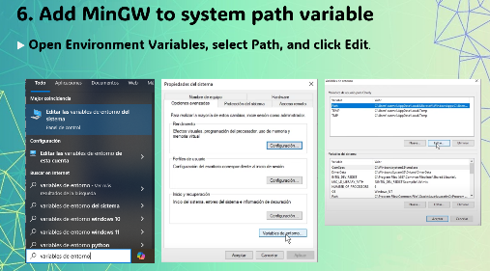

Once the installation is complete, we need to configure “configuier” the system path “paZ”.

In the Windows search menú “méniu”, search for **'Environment Variables' “envaiermen vériabels”** and open the result “Risolt”.

A new “anu” window will appear. There, click on the **'Environment Variables'** button.

Finally, find the **'Path'** “PAZ” variable **vériabel** in the list and select “seléct” 'Edit “éRit”

En bayer ment - environment ( envaier ment) - embayerment

Once the “di” installation is done,

we are going to execute, again the same command “cománd” that we saw in step 2

but this time we are going to see the version of C ++

Now you can compile C++ programs.

Create a test file to verify “tu vérafai” that everything works correctly. (corré cly)

~~Now, let's locate the MinGW 'bin' folder.   
You can see the exact path in our presentation.  
 Simply copy the full path from the address bar, then paste it into the Environment Variables windons, in the systpath list, clck new, paste the path there an click to save~~